Walkthrough 28 Unit Test with QUnit

https://sapui5.hana.ondemand.com/#/topic/e1ce1de315994a02bf162f4b3b5a9f09

Core Changed Codes Compared to Last Version:

1 test/integration/opaTests.qunit.html 新建集成测试显示界面

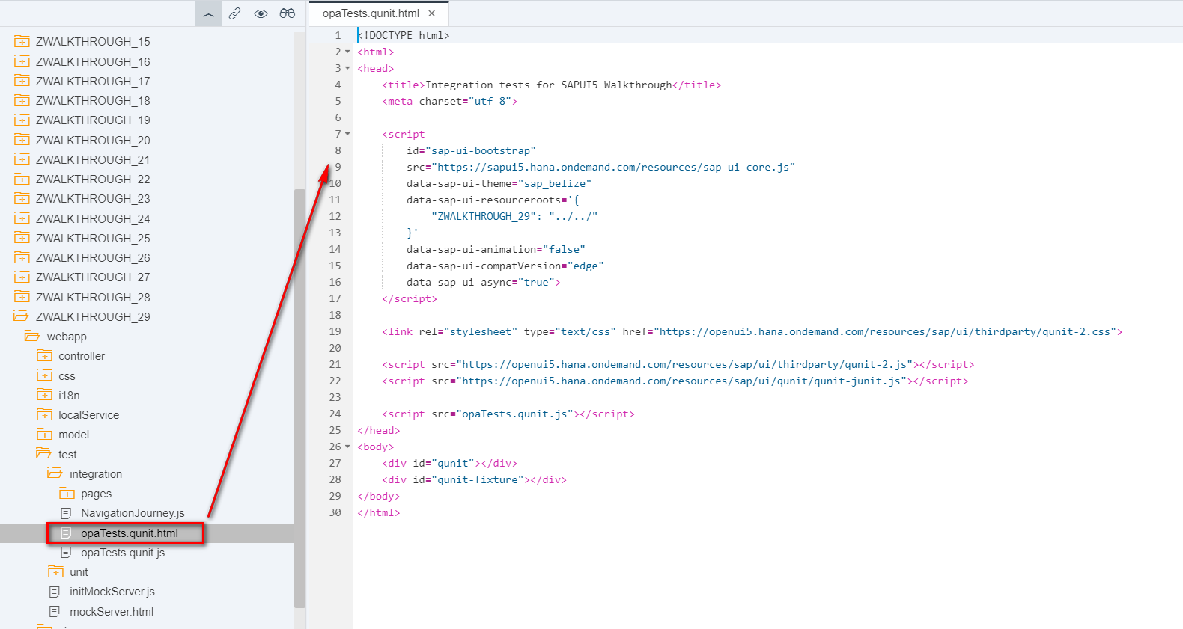

2 test/unit/opaTests.qunit.js 加载NavigationJourney.js,启动Qunit.test

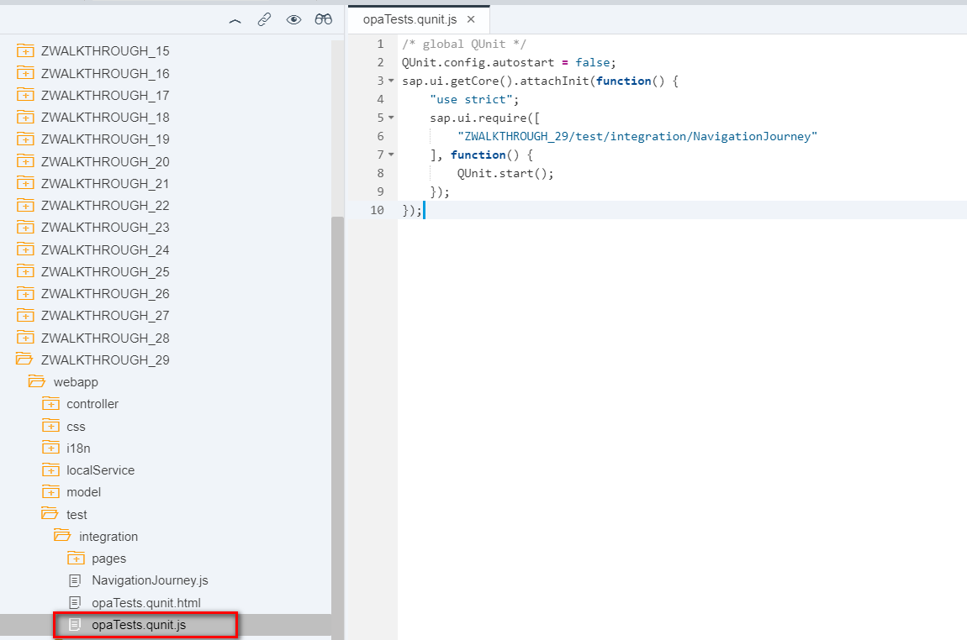

3. test/integration/NavigationJourney.js

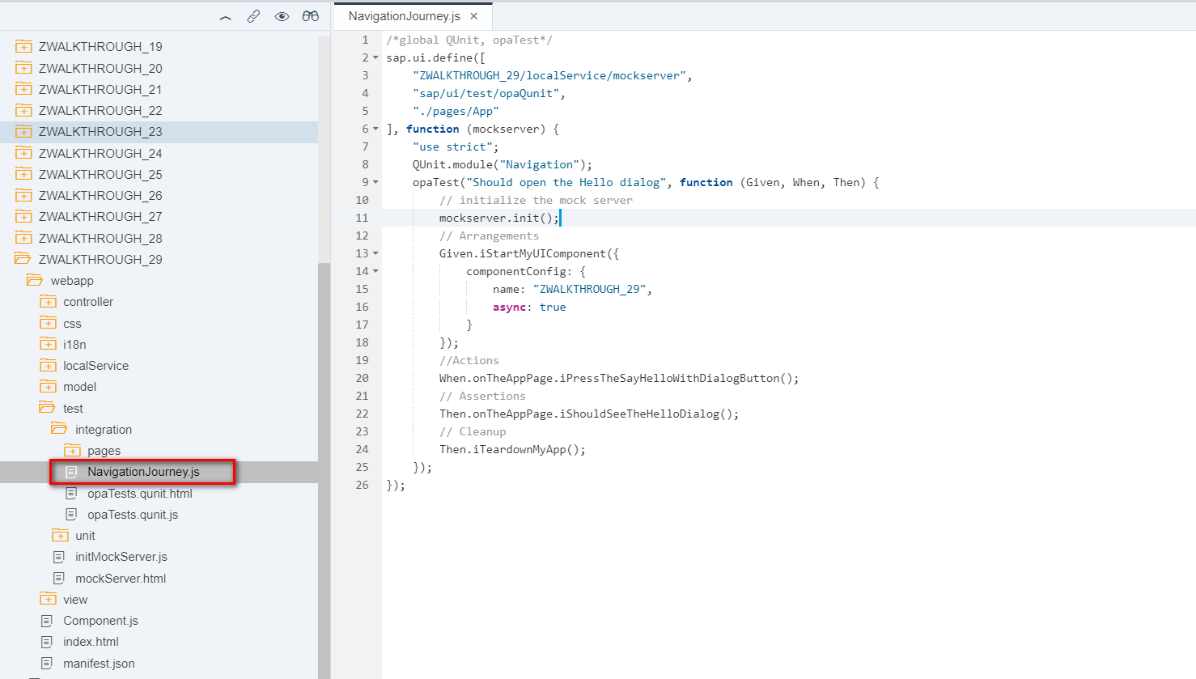

4. test/integration/pages/App.js UI交互case侦测指定按钮出现以及指定对话框打开

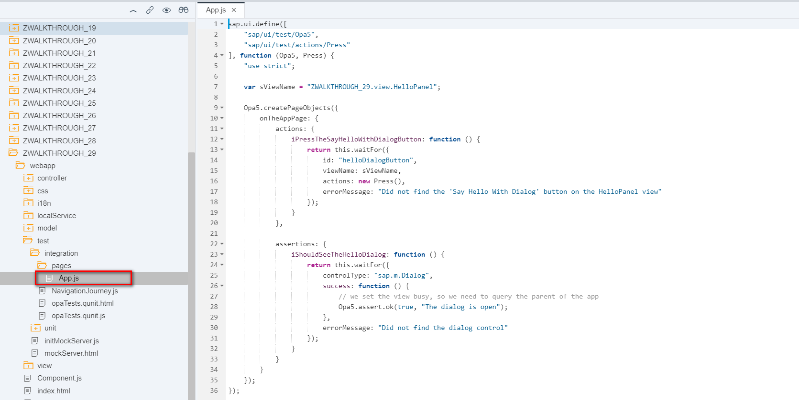

i18n 文本对象管理

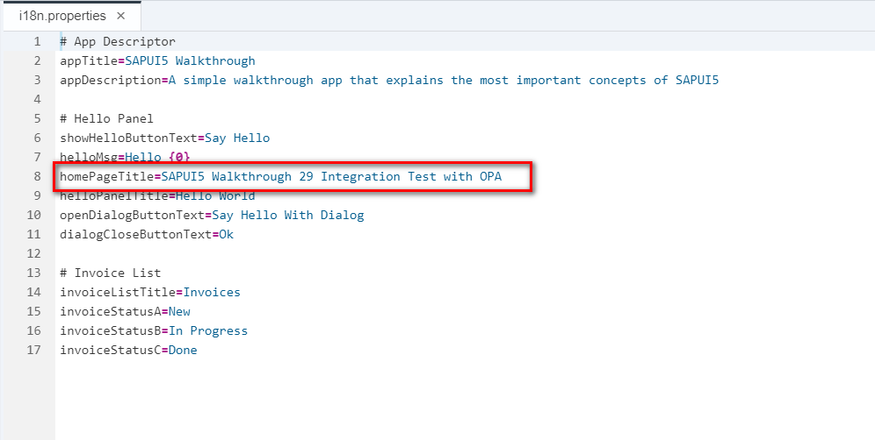

Result

Positive

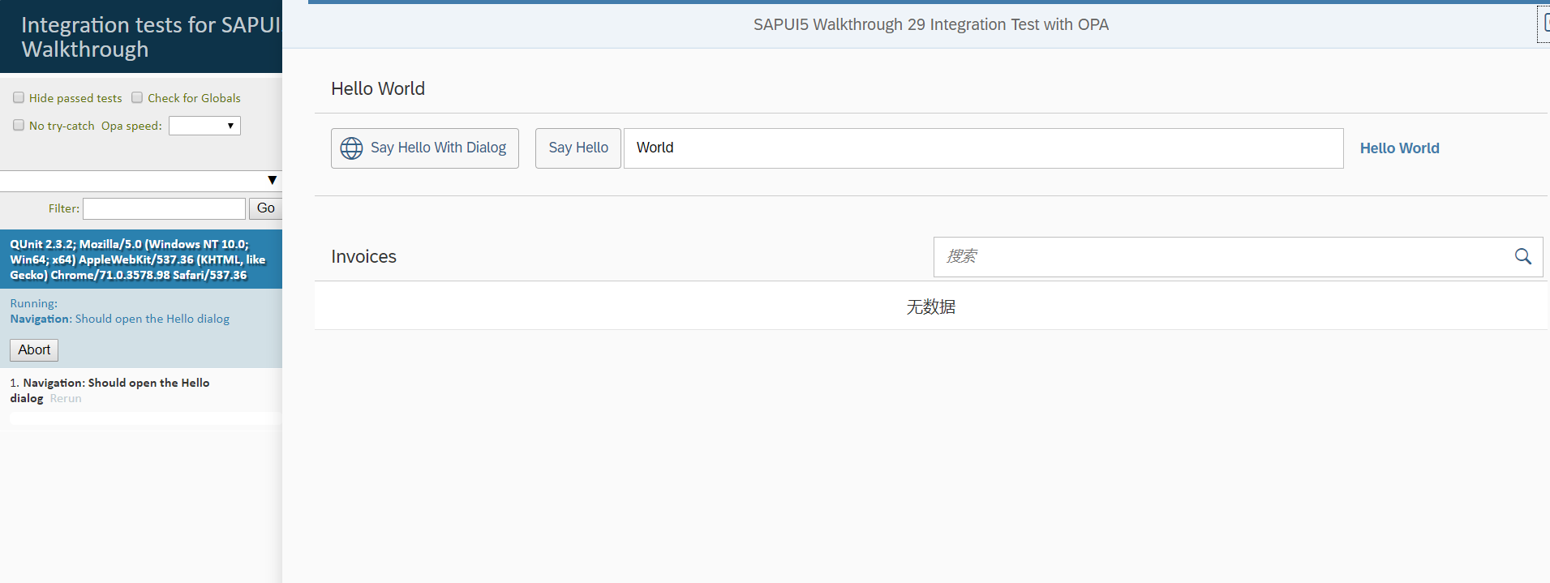

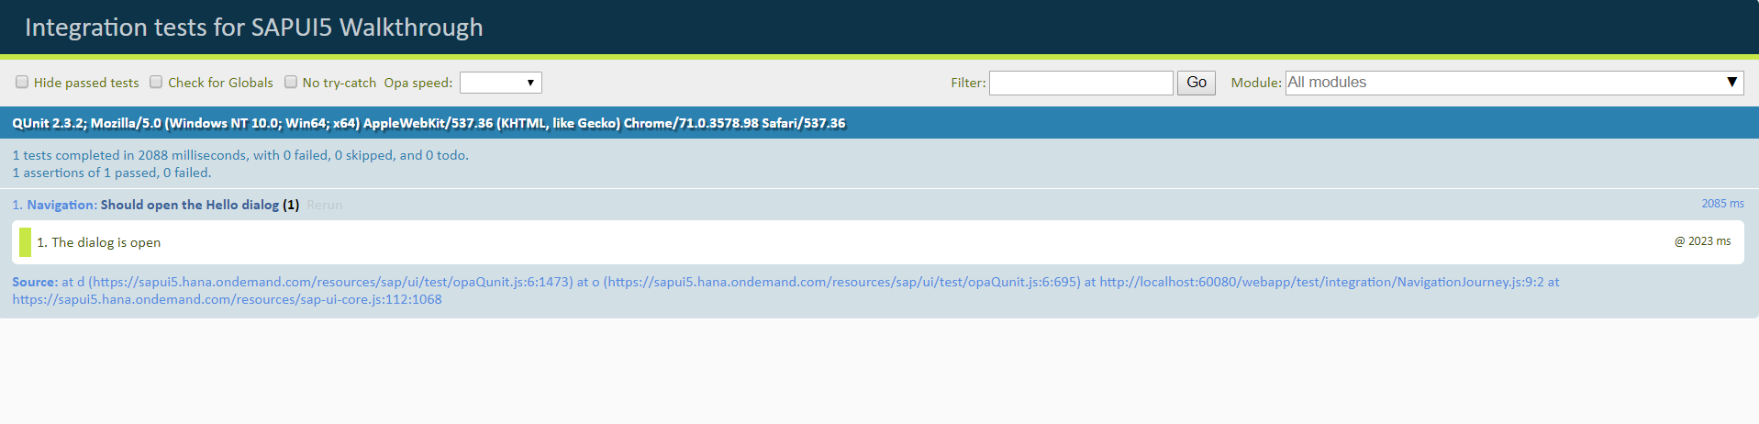

Negative

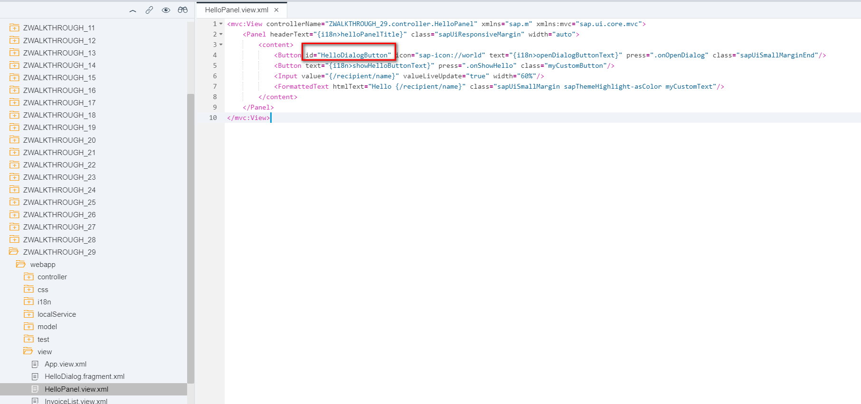

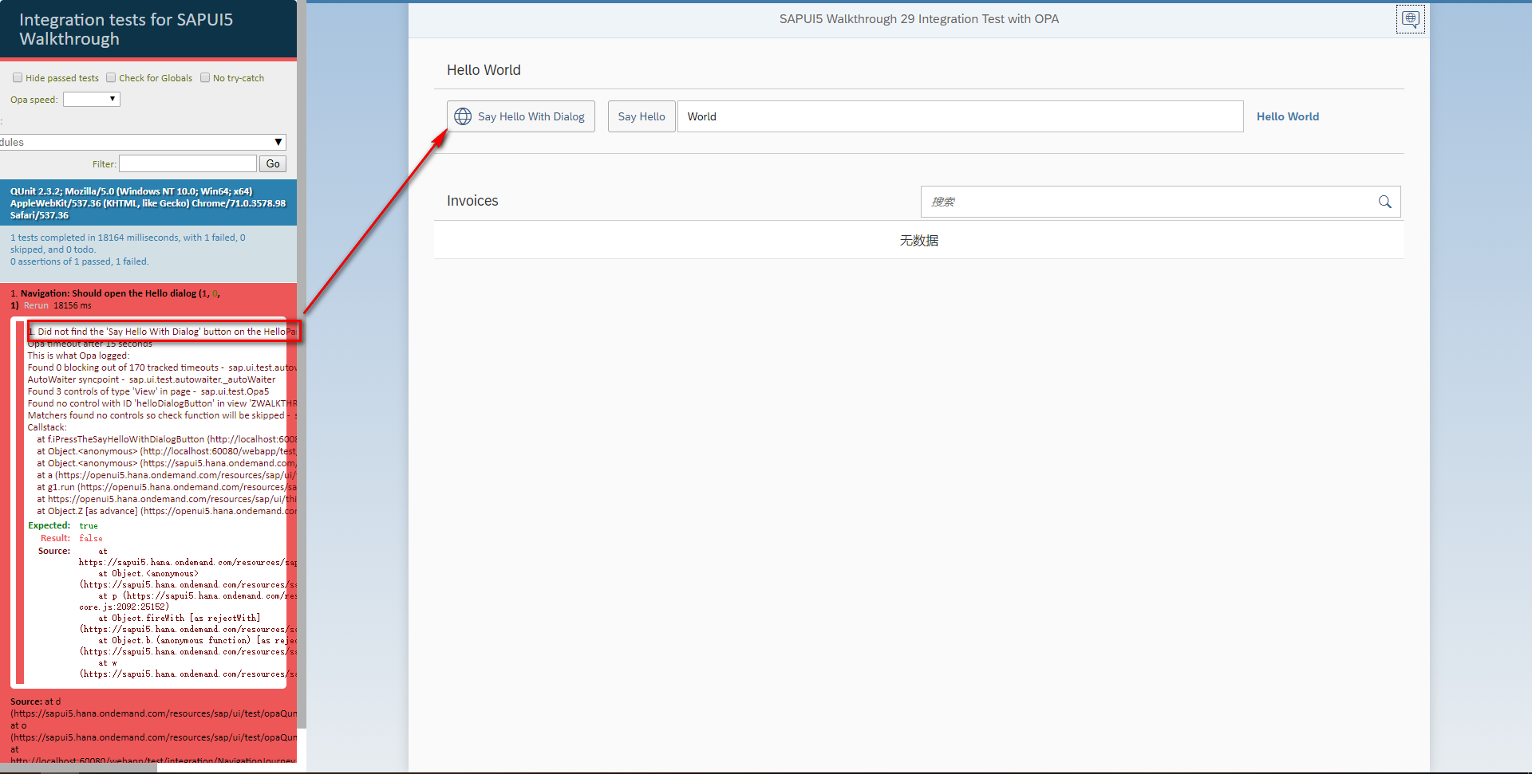

Git:

https://github.com/xiexiaop/SAPUI5-2-Round/tree/master/Projects/ZWALKTHROUGH_29

2019/02/07 XiaoMi Beijing Zac,Xie